1
Ans: A
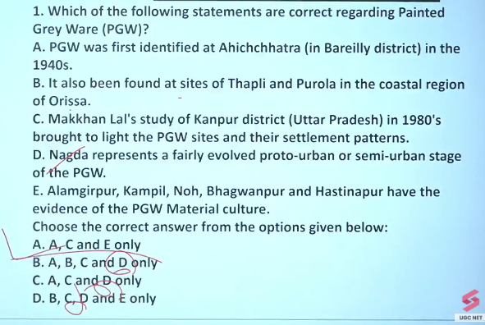
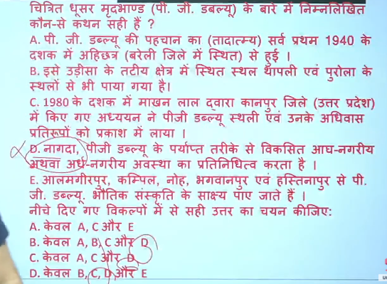


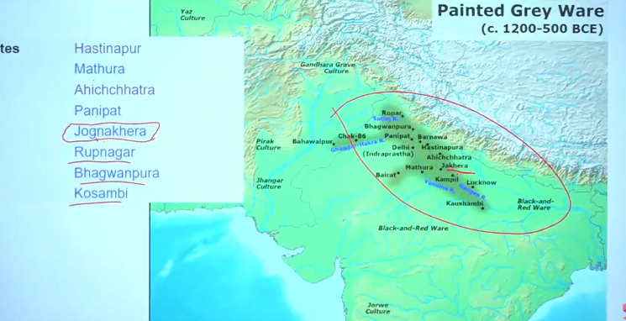
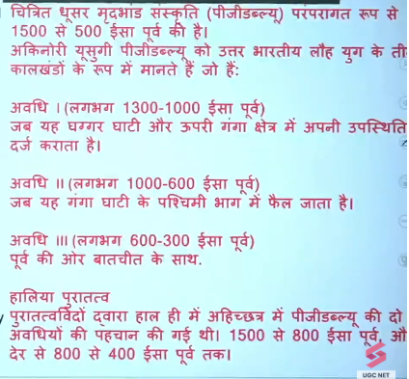
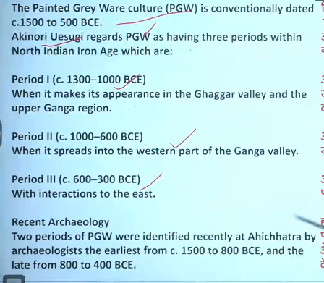

2

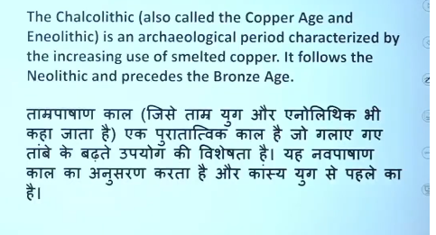
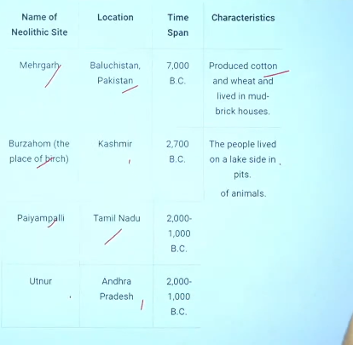

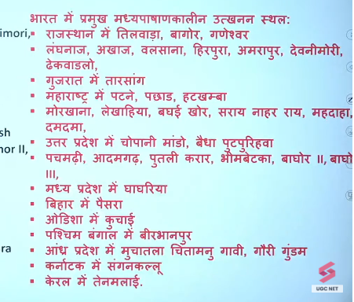
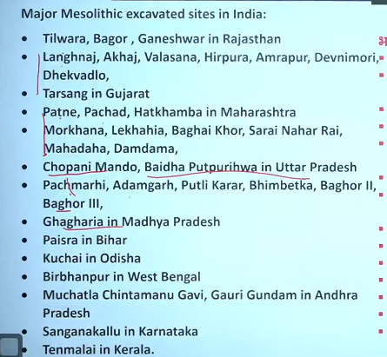
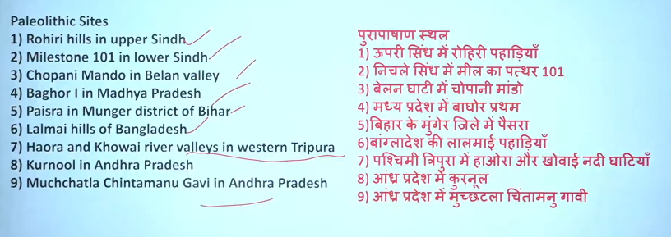

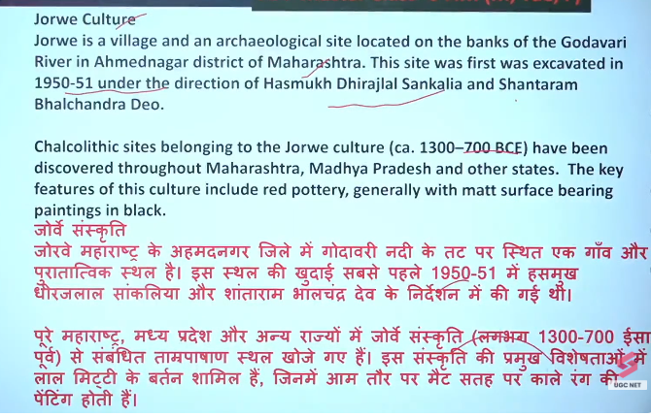
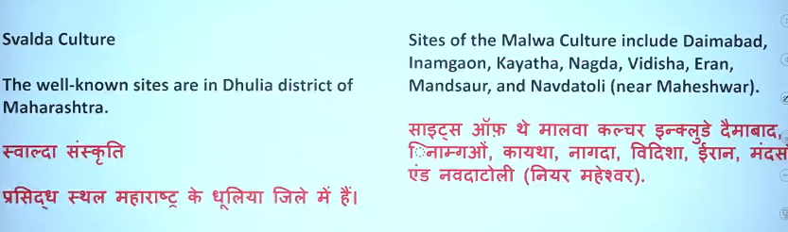
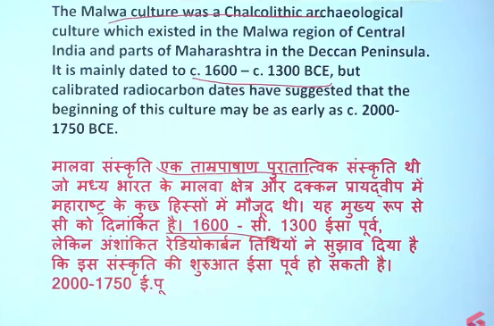
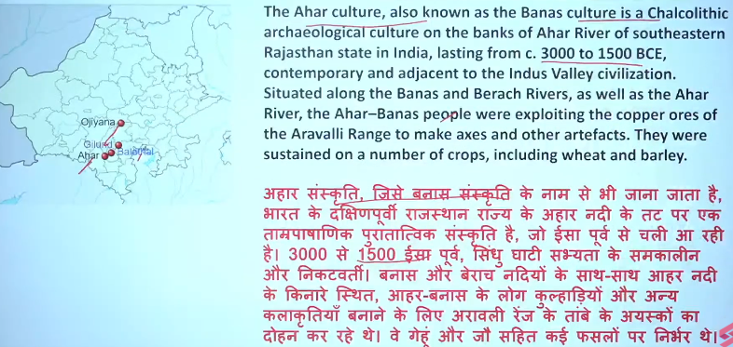

4
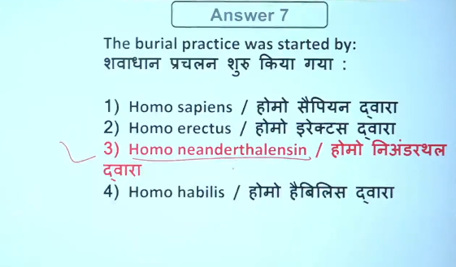

6 theory of hadddapan decline civilization
🔹 1. Aryan Invasion Theory
- 👤 Historian: Mortimer Wheeler
👉 Aryans invaded and destroyed Harappan cities
❗ Now largely rejected

🔹 2. Flood Theory
- 👤 Historian: R. L. Raikes
👉 Repeated floods (especially in Mohenjo-daro) caused destruction

🔹 3. River Shift / Drying Theory
- 👤 Scholars: Many historians (no single name fixed)
👉 Rivers like Ghaggar-Hakra dried or changed course
👉 Agriculture collapsed → cities declined

🔹 4. Climate Change / Drought Theory
- 👤 Historian: D. P. Agrawal
👉 Decrease in rainfall → drought → decline

🔹 5. Tectonic / Earthquake Theory
- 👤 Linked with: R. L. Raikes
👉 Earthquakes changed river courses and destroyed settlements

🔹 6. Ecological Degradation Theory
- 👤 Scholars: Modern historians
👉 Overuse of land, deforestation, soil exhaustion

🔹 7. Trade Decline Theory
- 👤 Linked with: General archaeological studies
👉 Decline in trade with Mesopotamia → economic collapse

🔥 Most Accepted View (UPSC)
👉 No single cause
👉 Combination of:
- Climate change
- River shift
- Environmental factors

📝 Final UPSC Line:
👉 The decline of the Harappan Civilization is explained by multiple factors such as climate change (D. P. Agrawal), floods and tectonic activity (R. L. Raikes), river shifts, and economic decline, while the Aryan invasion theory (Mortimer Wheeler) is largely rejected.

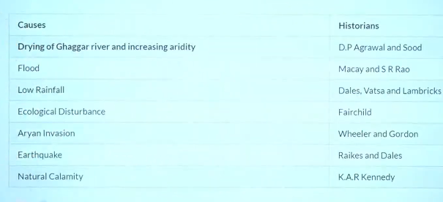

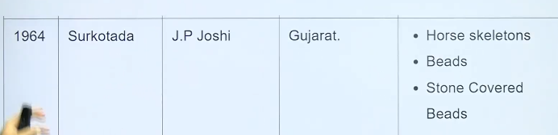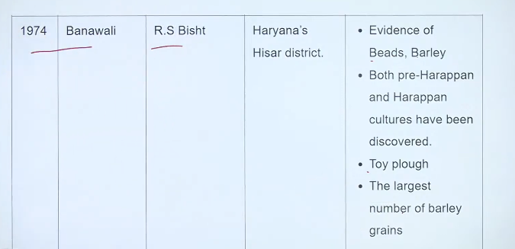

8
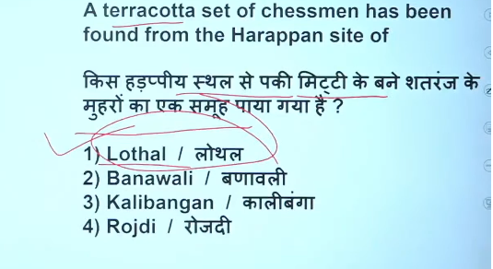
Ans: 1

9
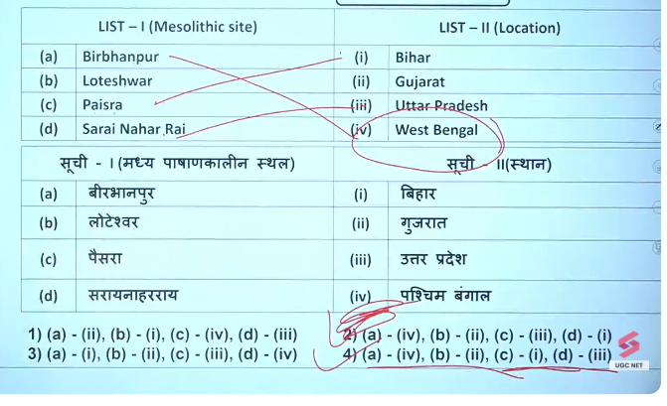

Ans:4
10
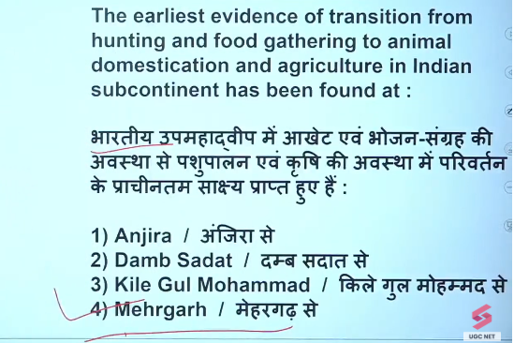
Ans:4

12
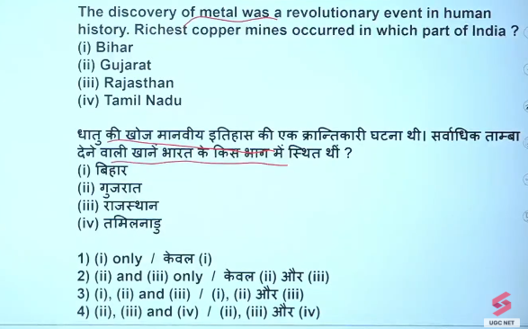
Ans: 3
Bihar, rajastan , gujrat
13
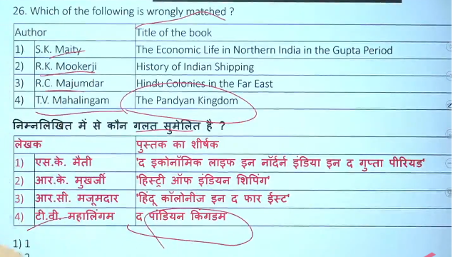


56
